**SQL WORKSHEET-4**

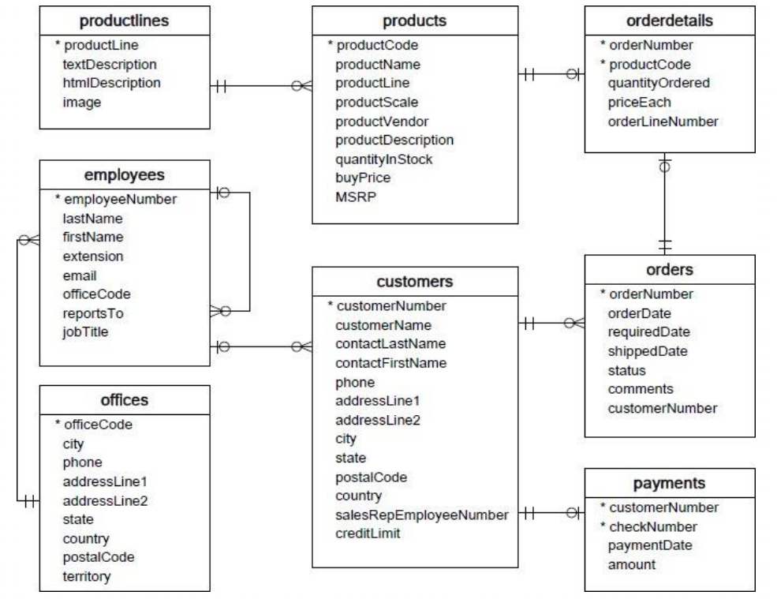

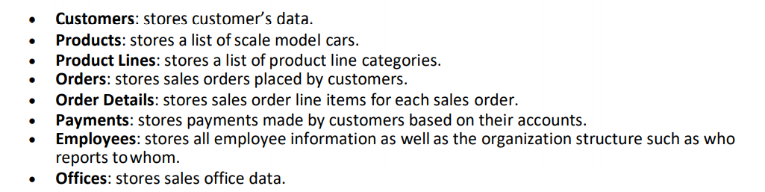

**QUESTIONS:**

**1. Write a SQL query to show average number of orders shipped in a day (use Orders table).**

ANS1.

select avg(daily_counts)

from(

SELECT

count(orderNumber) as daily_counts

FROM

orders

GROUP BY shippedDate) as orders_per_day;

**2. Write a SQL query to show average number of orders placed in a day.**

**ANS2.**

select avg(daily_placed_counts)

from(

SELECT

count(orderNumber) as daily_placed_counts

FROM

orders

GROUP BY orderDate) as orders_placed_per_day

**3. Write a SQL query to show the product name with minimum MSRP (use Productstable).**

**ANS3.**

SELECT

productName,

MIN(MSRP)

FROM

products

GROUP BY productName

ORDER BY MIN(buyPrice)

limit 1;

**4. Write a SQL query to show the product name with maximum value ofstockQuantity.**

**ANS4.**

SELECT

productName,

MAX(QuantityInStock)

FROM

products

GROUP BY productName

ORDER BY MAX(QuantityInStock)

DESC

limit 1;

**5. Write a query to show the most ordered product Name (the product with maximum number of**

**orders).**

**ANS5.** SELECT

productName,

SUM(quantityOrdered) as total

FROM

orderdetails

INNER JOIN

products on orderdetails.productCode=products.productCode

GROUP BY productCode

ORDER BY total

DESC

limit 1;

**6. Write a SQL query to show the highest paying customer Name.**

**ANS6.** SELECT

customerName, SUM(amount) as total_amt

FROM

payments

INNER JOIN

customers on payments.productCode=customers.productCode

GROUP BY customerNumber

ORDER BY total_amt

DESC

Limit 1;

**7. Write a SQL query to show cutomerNumber, customerName of all the customers who are from**

**Melbourne city.**

ANS7. SELECT customerNumber, customerName FROM customers where city='Melbourne';

**8. Write a SQL query to show name of all the customers whose name start with “N”.**

**ANS8.** SELECT customerName FROM customers where customerName like 'N%';

**9. Write a SQL query to show name of all the customers whose phone start with ‘7’ and are from city**

**‘LasVegas’.**

**ANS9.** SELECT customerName FROM customers where phone like '7%' and city='Las Vegas';

**10. Write a SQL query to show name of all the customers whose creditLimit < 1000 and city is either**

“Las Vegas” or ”Nantes” or “Stavern”.

SELECT customerName FROM customers

where creditLimit< 1000 and

(city = 'Las Vegas' or city = 'Nantes' or city = 'Stavern');

**11. Write a SQL query to show all the orderNumber in which quantity ordered <10.**

**AN11.** SELECT orderNumber FROM orderdetails where quantityOrdered<10;

**12. Write a SQL query to show all the orderNumber whose customer Name start with letter ‘N’.**

**ANS12.**

SELECT

orderNumber

FROM

orders

INNER JOIN customers

ON orders.customerNumber = customers.customerNumber

where customerName like 'n%';

**13. Write a SQL query to show all the customerName whose orders are “Disputed” in status.**

**ANS13.**

SELECT

customerName

FROM

orders

INNER JOIN customers

ON orders.customerNumber = customers.customerNumber

where status = 'Disputed';

**14. Write a SQL query to show the customerName who made payment through cheque with**

**checkNumber startingwith H and made payment on “2004-10-19”.**

**ANS14.**

SELECT

customerName

FROM

payments

INNER JOIN customers

ON payments.customerNumber = customers.customerNumber

where checkNumber like 'H%' and paymentDate='2004-10-19';

**15. Write a SQL query to show all the checkNumber whose amount > 1000.**

**ANS15.** SELECT checkNumber FROM payments where amount >1000;